**HONORS BIOLOGY SUMMER ASSIGNMENT**

**2020-21 SCHOOL YEAR**

In Honors Biology at A. R. Johnson Health Science and Engineering Magnet School you will be participating in numerous laboratory experiences and projects that allow for higher levels of thinking and creativity. An inquiry approach is frequently used in this fast-paced course while applying scientific content knowledge and concepts. Thus, an excellent method for understanding such concepts is to gain first exposure to learning prior to class, via readings and/or video lectures, then focus on the processing part of learning in class through problem solving, discussion, or debates.

Honors Biology is an advanced courses that will require time, commitment and independent study. The following summer assignment will refresh science skills and test your commitment, as well. Your summer assignment will be to **watch and take notes** on several Khan Academy videos in the Chemistry Unit. You must complete **ALL** of the lessons in the unit and do the practice. The concepts in these videos will be applied within the first weeks of school. Each assignment is due the first day of class. None will be accepted late. Students adding the course after the first day will be required to complete the entire assignments as well.

Below are the directions for accessing your Khan Academy account along with the recommended video list. You **must** be logged into this account via the direction to verify you’ve viewed the videos.

**Khan Academy Sign-up Directions:**

1. Go to https://www.khanacademy.org/

1. Click “Sign Up” at the top right corner.



**Click**

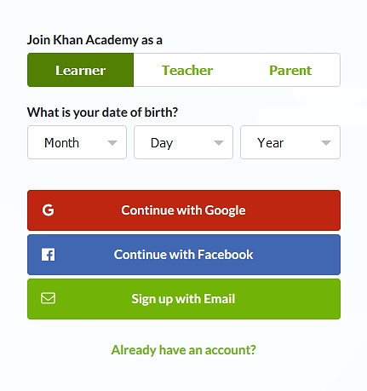

**Click**

1. You **must** “Sign in / Sign Up” with your school email address (ex: watkika@richmond.k12.ga.us). *If you do not already have a school email account setup for Khan Academy, you will need to click “Create a new account” and follow the new account directions.

1. After signing in, you will notice your full name at the top right of the screen. Click on your name, then click “Profile”.

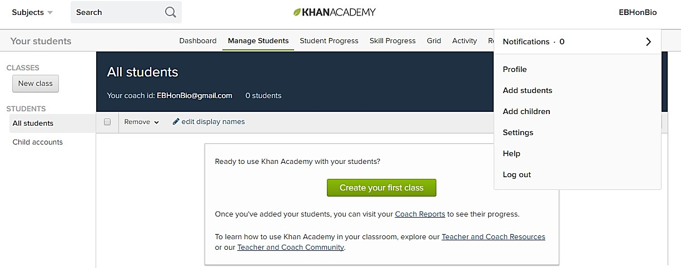

**Click**

1. Next, click on “Teacher/Coaches.”

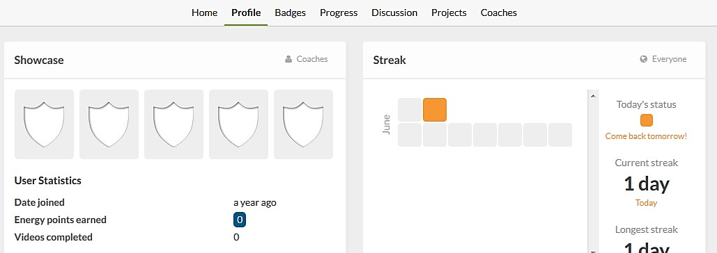

**Click**

1. Then, add the following code in the “Join a class” box to join the honors biology summer assignment class. **CODE: PJNKR4NG**

IMPORTANT: Add your parent’s email address so they too can view your progress and encourage your learning.

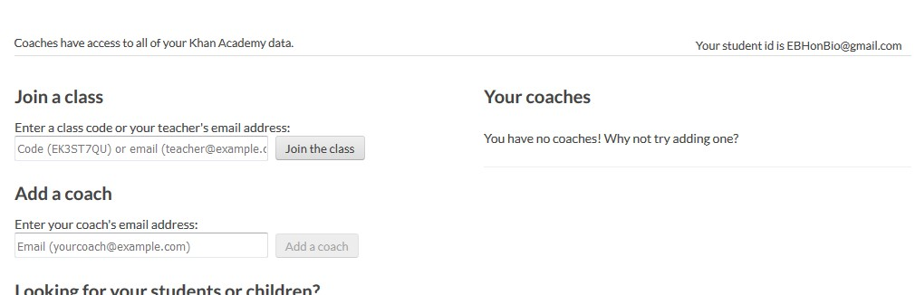

**Insert Code JRKR96CV**

**and join the class**

*There is also a Khan Academy app that can be downloaded to your personal device to watch videos while away from a desktop computer. Be sure to login with your school email account!* *Complete all of the lessons in each section and do the practice.*

**Khan Academy Video Watch list**

**Unit: Chemistry of Life:** Learn how chemistry makes life possible! From you, to your dog, to your dinner, to the global ecosystem, all living systems are made out of atoms that obey the basic rules of chemistry. Here, you can learn about the key properties of atoms, including what particles they contain, how they are organized, and how they form chemical bonds with one another. Read and watch all of the sections in each section and do the practice.

* **Elements and Atoms (4)**
* **Electron shells and orbitals (4)**
* **Chemical bonds and reactions (8)**

**DUE: THE FIRST DAY OF CLASS.**